Handout Contact simulation
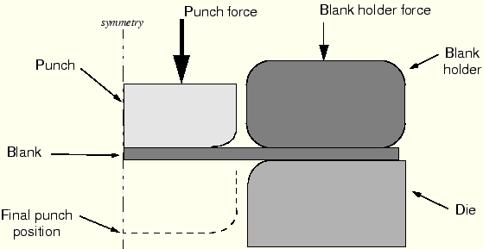
Problem description: Forming of channel in long metal sheet with punch.
The blank is 1 mm thick and is squeezed between the blank holder and the die. The blank holder force is 440 kN.
Dimensions, in m, of the components in the forming simulation.
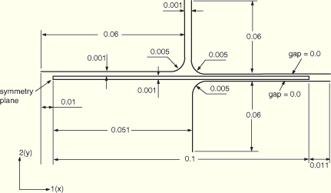

Preprocessing—creating the model with ABAQUS/CAE
Part definition
You will have to create four parts: a deformable part representing the blank and three rigid parts representing the tools.
Deformable blank
Create a two-dimensional, deformable solid part with a planar shell base feature to represent the deformable blank. Use an approximate part size of 0.25, and name the part Blank. To define the geometry, sketch a rectangle of arbitrary dimensions using the connected lines tool. Then, dimension the horizontal and vertical lengths of the rectangle, and edit the dimensions to define the part geometry precisely. 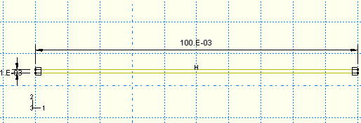
Rigid tools
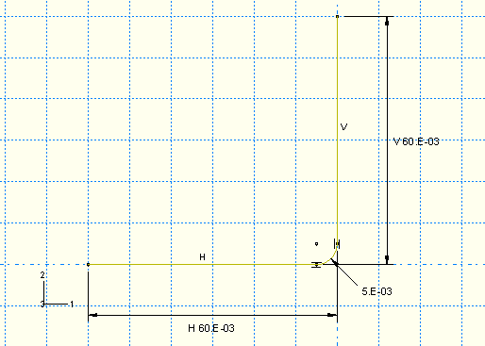
You must create a separate part for each rigid tool. Each of these parts will be created using very similar techniques so it is sufficient to consider the creation of only one of them (for example, the punch) in detail. Create a two-dimensional planar, analytical rigid part with a wire base feature to represent the rigid punch. Use an approximate part size of 0.25, and name the part Punch. Using the Create Lines and Create Fillet tools, sketch the geometry of the part. Create and edit the dimensions as necessary to define the geometry precisely.
A rigid body reference point must be created. Exit the Sketcher when you are finished defining the part geometry to return to the Part module. From the main menu bar, select ToolsReference Point. In the viewport, select the point at the center of the arc as the rigid body reference point.
Next, create two additional analytical rigid parts named Holder and Die, representing the blank holder and rigid die, respectively. Use copy part and mirror sketch to complete create these two parts.
Material and section properties
The blank is made from a high-strength steel (elastic modulus of 210.0 × 10⁹ Pa, = 0.3). Its inelastic stress-strain behavior is tabulated below.
Yield stress (Pa) | Plastic strain
400.0E6 | 0.0
420.0E6 | 2.0E–2
500.0E6 | 20.0E–2
600.0E6 | 50.0E–2
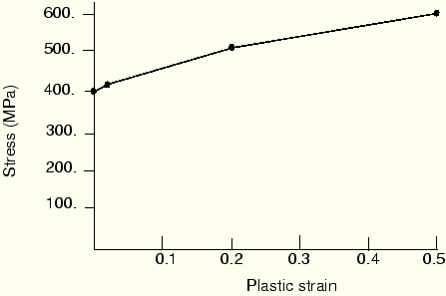

Create a material named Steel with these properties. Create a homogeneous solid section named BlankSection that refers to the material Steel. Assign the section to the blank.
The blank is going to undergo significant rotation as it deforms. Reporting the values of stress and strain in a coordinate system that rotates with the blank's motion will make it much easier to interpret the results. Therefore, a local material coordinate system that is aligned initially with the global coordinate system but moves with the elements as they deform should be created. To do this, create a rectangular datum coordinate system using the Create Datum CSYS: 3 Points tool. From the main menu bar of the Property module, select AssignMaterial Orientation. Select the blank as the region to which the local material orientation will be assigned, and pick the datum coordinate system in the viewport as the CSYS (select Axis 1 and accept None for the additional rotation options).

Assembling the parts
Begin by instancing the blank. Then, instance and position the rigid tools using the techniques described below.
To instance and position the punch:
- In the Model Tree, double-click Instances underneath the Assembly container and select Punch as the part to instance.
- The bottom of the punch initially rests 0.001 m from the top of the blank. From the main menu bar, select ConstraintEdge to Edge to position the punch vertically with respect to the blank.
- Choose the horizontal edge of the punch as the straight edge of the movable instance and the edge on the top of the blank as the straight edge of the fixed instance.
Arrows appear on both instances. The punch will be moved so that its arrow points in the same direction as the arrow on the blank.
- If necessary, click Flip in the prompt area to reverse the direction of the arrow on the punch so that both arrows point in the same direction; otherwise, the punch will be flipped. When both arrows point in the same direction, click OK.
- Enter a distance of 0.001 m to specify the separation between the instances.
- The vertical edge of the punch is 0.05 m from the left edge of the blank. Define another Edge to Edge constraint to position the punch horizontally with respect to the blank.
Select the vertical edge of the punch as the straight edge of the movable instance and the left edge of the blank as the straight edge of the fixed instance. Flip the arrow on the punch if necessary so that both arrows point in the same direction. Enter a distance of –0.05 m to specify the separation between the edges. (A negative distance is used since the offset is applied in the direction of the edge normal. The edge normal points away from the edge of the blank.)
To instance and position the blank holder:
The holder is initially positioned so that its horizontal edge is offset a distance of 0.0 m from the top edge of the blank and its vertical edge is offset a distance of 0.001 m from the vertical edge of the punch. Define the necessary Edge to Edge constraints to position the blank holder.

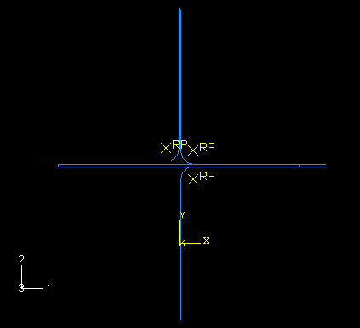
To instance and position the die:
The die is initially positioned so that its horizontal edge is offset a distance of 0.0 m from the bottom edge of the blank and its vertical edge is offset a distance of 0.051 m from the left edge of the blank. Define the necessary Edge to Edge constraints to position the die.

Geometry sets
Six sets should be created: one at each rigid body reference point, one at the symmetry plane of the blank, and one at each end of the blank midplane. The last two sets require that a vertex first exist at these locations; an edge partition can be performed to satisfy this requirement.
Begin by partitioning the vertical edges of the blank in half using the procedure described below.
To create vertices on the blank midplane:
- In the Model Tree, double-click the part named Blank underneath the Parts container. Partition the left and right vertical edges of the blank using the Partition Edge: Enter Parameter tool. For each edge, specify a normalized edge parameter of 0.5 to partition the edge in half.
Each vertical edge of the blank now has a vertex located on the blank midplane.
- Double-click the Sets item underneath the Assembly container to create the following geometry sets:
  - RefPunch at the punch rigid body reference point.
  - RefHolder at the holder rigid body reference point.
  - RefDie at the die rigid body reference point.
  - Center at the left vertical edge (symmetry plane) of the blank.
  - MidLeft at the left midplane vertex of the blank.
  - MidRight at the right midplane vertex of the blank.

Defining steps and output requests
Step 1
Create a static, general step named Establish contact I after the Initial step. Enter the following description for the step: Push the blank holder and die together; and include the effects of geometric nonlinearity.
The step should complete in one increment, so set the initial time increment and the total time to be equal (for example, 1.0).
To limit the amount of output, write the preselected field output only at the end of the step. In addition, you can delete the history output request for this step. Output for variables that you need to track using history data can be requested, when needed, at a later stage in the analysis. In addition, write contact diagnostics to the message file (OutputDiagnostic Print).
Step 2
Create a second static, general step. Name the second step Remove right constraint, and insert it after the Establish contact I step. Enter the following description for the step: Remove the middle constraint at right.
Since the previous step considers the effects of geometric nonlinearity, these effects will be included automatically in this and all subsequent general steps and cannot be removed.
Set the initial time increment and the total time to be equal (again, set them equal to 1.0). The field output request specified in the previous step will be propagated to this step. You should request contact diagnostic output for Step 2 as well.
Step 3
Create a third static, general step named Holder force, and insert it after the Remove right constraint step. Enter the following description for the step: Apply prescribed force on blank holder. This step will also complete in a single increment; therefore, again set the initial time increment to be equal to the total time period. Request contact diagnostic output for this step.
Step 4
Create a fourth static, general step named Establish contact II, and insert it after the Holder force step. Enter the following description for the step: Move the punch down a little while applying a small pressure to blank top. Set the initial time increment to 10% of the total time since the contact condition may be harder to establish in this step. Request contact diagnostic output for Step 4. In addition, request that the vertical reaction force and displacement (RF2and U2) at the punch reference point (geometry set RefPunch) be written every increment as history data.
Step 5
In the fifth and final step the pressure load applied to the blank will be removed, and the punch will be moved down to complete the forming operation.
Create a fifth static, general step named Move punch, and insert it after the Establish contact II step. Enter the following description for the step: Full extent. Because of the frictional sliding, the changing contact conditions, and the inelastic material behavior, there is significant nonlinearity in this step; therefore, set the maximum number of increments to a large value (for example, 1000). Set the initial time increment to 0.0001, the total time period to 1.0, and the minimum time increment to 1e–06. With these settings ABAQUS/Standard can take smaller time increments during the highly nonlinear parts of the response without terminating the analysis. Specify that the preselected field output be written every 20 increments for this step. Your history output request for the punch reaction forces from the previous step will be propagated to this step. Remember to specify the contact diagnostics output request as well. In addition, request that the restart file be written every 200 increments for Step 5.
Monitoring the value of a degree of freedom
- From the main menu bar of the Step module, select OutputDOF Monitor.
- Toggle on Monitor a degree of freedom throughout the analysis.
- Click Edit to select the region. In the prompt area, click Points. In the Region Selection dialog box that appears, selectRefPunch; and click Continue.
- In the Degree of freedom text field, enter 2.
- Accept the default frequency (every increment) at which this information will be written to the message file.
- Click OK to exit the DOF Monitor dialog box.
Defining contact interactions
Define the following surfaces: BlankTop on the top edge of the blank; BlankBot on the bottom edge of the blank; DieSurf on the side of the die that faces the blank; HolderSurf on the side of the holder that faces the blank; and PunchSurf on the side of the punch that faces the blank.
Now define two contact interaction properties. (In the Model Tree, double-click the Interaction Properties container to create a contact property.) Name the first one NoFric; since frictionless contact is the default in ABAQUS, accept the default property settings for the tangential behavior (select MechanicalTangential Behavior in the Edit Contact Property dialog box). The second property should be named Fric. For this property use the Penalty friction formulation with a friction coefficient of 0.1.
Finally, define the interactions between the surfaces and refer to the appropriate contact interaction property for each definition. (In the Model Tree, double-click the Interactions container to define a contact interaction.) In all cases define the interactions in the Initial step and use the default finite-sliding formulation (Surface-to-surface contact (Standard)). The following interactions should be defined:
- Die-Blank between surfaces DieSurf (master) and BlankBot (slave) referring to the Fric contact interaction property.
- Holder-Blank between surfaces HolderSurf (master) and BlankTop (slave) referring to the Fric contact interaction property.
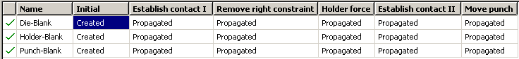
- Punch-Blank between surfaces PunchSurf (master) and BlankTop (slave) referring to the NoFric contact interaction property.
Boundary conditions for Step 1
Constrain the blank holder and die in degrees of freedom 1 and 6, where degree of freedom 6 is the rotation in the plane of the model. All of the boundary conditions for the rigid surfaces are applied to their respective rigid body reference nodes. Constrain the punch completely, and apply symmetric boundary constraints on the region of the blank lying on the symmetry plane (geometry set Center).
BC Name | Geometry Set | BCs
CenterBC | Center | XSYMM
RefDieBC | RefDie | U1 = UR3 = 0.0, U2 = 1.E–08
RefHolderBC | RefHolder | U1 = UR3 = 0.0, U2 = –1.E–08
RefPunchBC | RefPunch | U1 = U2 = UR3 = 0.0
MidLeftBC | MidLeft | U2 = 0.0
MidRightBC | MidRight | U2 = 0.0

Boundary conditions for Step 2
Now that contact between the blank and the blank holder and die has been established, the blank is fully constrained in the 2-direction. Therefore, deactivate the boundary condition on the right side of the midplane of the blank (it is no longer necessary). To do this, open the Boundary Condition Manager and click the cell under Remove right constraint in the row for boundary condition MidRightBC. Click Deactivate on the right side of the dialog box.
Loading and boundary conditions for Step 3
Using the Boundary Condition Manager, edit the RefHolderBC boundary condition in Step 3 to remove the constraint on U2.
Create a mechanical concentrated force in this step named RefHolderForce. Apply the load to set RefHolder in step Holder force. Specify a magnitude of –440.E3 for CF2.
Loading and boundary conditions for Step 4
Using the Boundary Condition Manager, deactivate the MidLeftBC boundary condition in Step 4 and change theRefPunchBC boundary condition to specify a value of –0.001 for U2.
Create a mechanical pressure load named Small pressure. Apply the load to the surface BlankTop in step Establish contact II. Specify a magnitude of -1000.0.
Loading and boundary conditions for Step 5
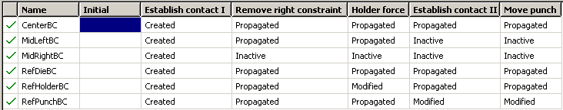
Using the Load Manager, deactivate the Small pressure load in this step. Using the Boundary Condition Manager, edit the RefPunchBC boundary condition to specify a value of –0.031 for U2. This represents the total displacement of the punch, accounting for the initial offset of 0.001 m.

Mesh creation and job definition
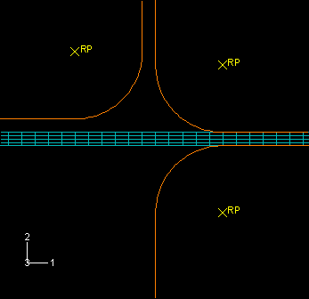
Mesh the blank using either the sweep or structured mesh techniques with CPE4R elements.
Seed the edges of the blank by specifying the number of elements along each edge. Specify 100 elements along the horizontal edges of the blank and 2 elements along each region on the vertical edges of the blank (recall these edges were partitioned earlier, so in effect there will be four elements along each vertical edge).
Create a job named Channel. Give the job the following description: Analysis of the forming of a channel. Save your model to a model database file, and submit the job for analysis. Monitor the solution progress, correct any modeling errors that are detected, and investigate the cause of any warning messages.
Once the analysis is underway, an X–Y plot of the values of the degree of freedom that you selected to monitor (the punch's vertical displacement) appears in a separate viewport. From the main menu bar, select ViewportJob Monitor: Channel to follow the progression of the punch's displacement in the 2-direction over time as the analysis runs.

Job monitoring
This analysis should take approximately 165 increments to complete. 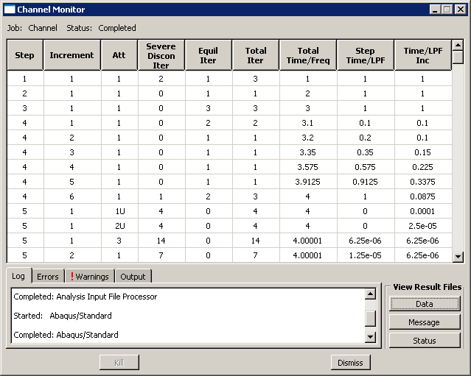
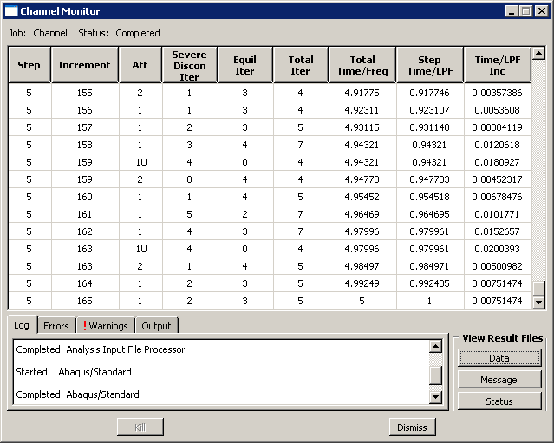

Troubleshooting ABAQUS/Standard contact analyses
Enter the Visualization module, and open the file Channel.odb to look at the contact diagnostics information. This can be seen in the Contact tabbed page of the Job Diagnostics dialog box. To see where the nodes are located on the model, toggle on Highlight selections in viewport.
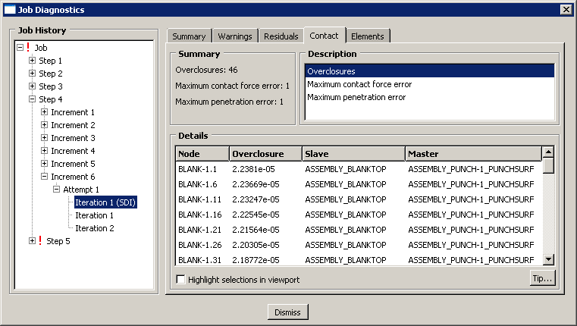

Postprocessing
In the Visualization module, examine the deformation of the blank.
Deformed model shape and contour plots
The basic result of this simulation is the deformation of the blank and the plastic strain caused by the forming process. We can plot the deformed model shape and the plastic strain, as described below.
To plot the deformed model shape:
- Plot the deformed model shape. You can remove the die and the punch from the display and visualize just the blank.
- In the Results Tree, expand the Instances container underneath the output database file named Channel.odb.
- From the list of available part instances, select BLANK-1. Click mouse button 3, and select Replace from the menu that appears to replace the current display group with the selected elements. Click , if necessary, to fit the model in the viewport.
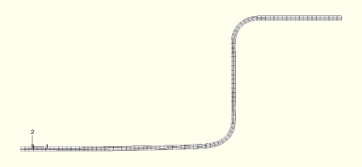
To plot the contours of equivalent plastic strain:
- From the main menu bar, select PlotContoursOn Deformed Shape; or click the tool from the toolbox to display contours of Mises stress.
- Open the Contour Plot Options dialog box.
- Drag the Contour Intervals slider to change the number of contour intervals to 7.
- Click OK to apply these settings.
- From the main menu bar, select ResultField Output.
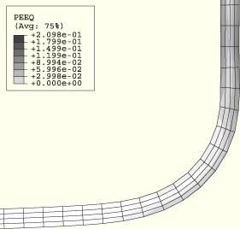
The Field Output dialog box appears.
- Select PEEQ from the Output Variable list.
PEEQ is an integrated measure of plastic strain. A non-integrated measure of plastic strain is PEMAG. PEEQ and PEMAG are equal for proportional loading.
- Click OK to apply these settings. Use the tool to zoom into any region of interest in the blank.
The maximum plastic strain is approximately 21%. Compare this with the failure strain of the material to determine if the material will tear during the forming process.
History plots of the reaction forces on the blank and punch
It is important to check that the force required to push the punch into the blank is much larger than the force created by the pressure applied to the surface of the blank. The force on the blank from the applied pressure is approximately 100 N (1000 Pa × 0.1 m × 1.0 m) at the start of Step 5. The solid line below shows the variation of the reaction force RF2 at the punch's rigid body reference node.
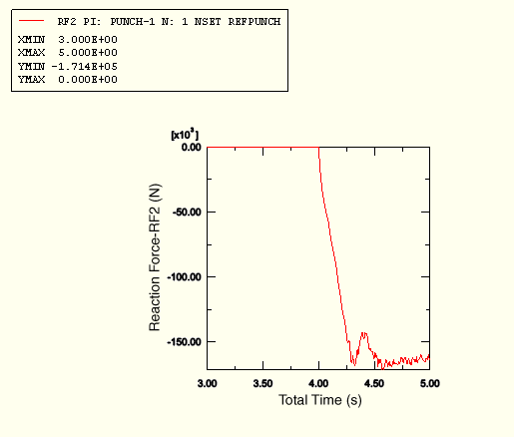
To create a history plot of the reaction force:
- In the Results Tree, expand the History Output container. Double-click Reaction force: RF1 PI: PUNCH–1 Node xxxin NSET REFPUNCH.
- Select and plot Reaction force: RF2 PI: PUNCH–1 Node xxx in NSET REFPUNCH.
- Open the Axis Options dialog box to label the axes.
- Switch to the Title tabbed page.
- Specify Reaction Force - RF2 as the Y-axis label, and Total Time as the X-axis label.
- Click Dismiss to close the dialog box.
The punch force, rapidly increases to about 160 kN during Step 5, which runs from a total time of 4.0 to 5.0. The punch force clearly is much larger than the force (100 N) created by the pressure load.
Plotting contours on surfaces
ABAQUS/CAE includes a number of features designed specifically for postprocessing contact analyses. Within the Visualizationmodule, the Display Group feature can be used to collect surfaces into display groups, similar to element and node sets.
To display contact surface normal vectors:
- Plot the undeformed model shape.
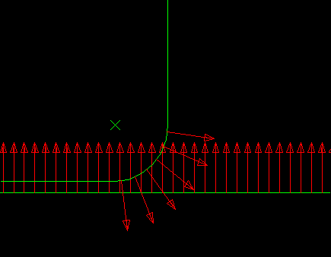
- In the Results Tree, expand the Surface Sets container. Select the surfaces named BLANKTOP and PUNCH-1.PUNCHSURF. Click mouse button 3, and select Replace from the menu that appears.
- Using the Common Plot Options dialog box, turn on the display of the normal vectors (On surfaces) and set the length of the vector arrows to Short.
To contour the contact pressure:
- Plot the contours of plastic strain again.
- From the main menu bar, select ResultField Output.
The Field Output dialog box appears.
- Select CPRESS from the Output Variable list.
- Click OK to apply these settings.
- Remove the PUNCH-1.PUNCHSURF surface from your display group.
To visualize contours of surface-based variables better in two-dimensional models, you can extrude the plane strain elements to construct the equivalent three-dimensional view. You can sweep axisymmetric elements in a similar fashion.
- From the main menu bar, select ViewODB Display Options.
The ODB Display Options dialog box appears.
- Select the Sweep/Extrude tab to access the Sweep/Extrude options.
- In the Extrude region of the dialog box, toggle on Extrude elements; and set the Depth to 0.05 to extrude the model for the purpose of displaying contours.
- Click OK to apply these settings.
Rotate the model using the tool to display the model from a suitable view.
